POI 2

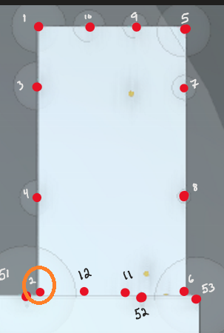

POI 2 is not reading extended. I tried placing another poi next to it definitively attached to the edge and that POI still did not read extended.

POI 6

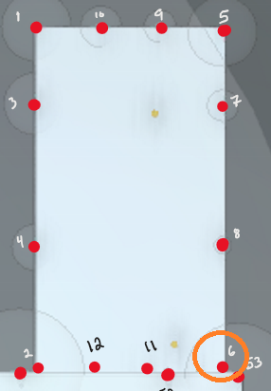

POI 6 does not read extended.

POI 9-10:

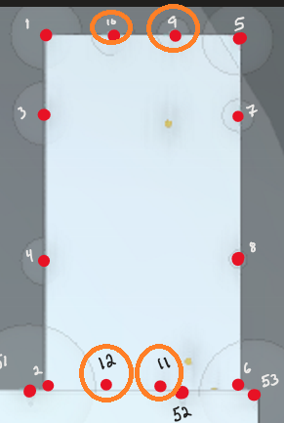

9 and 10 are coming in extended but pulling a multiplicative of 1.

These should be able to pull equation G

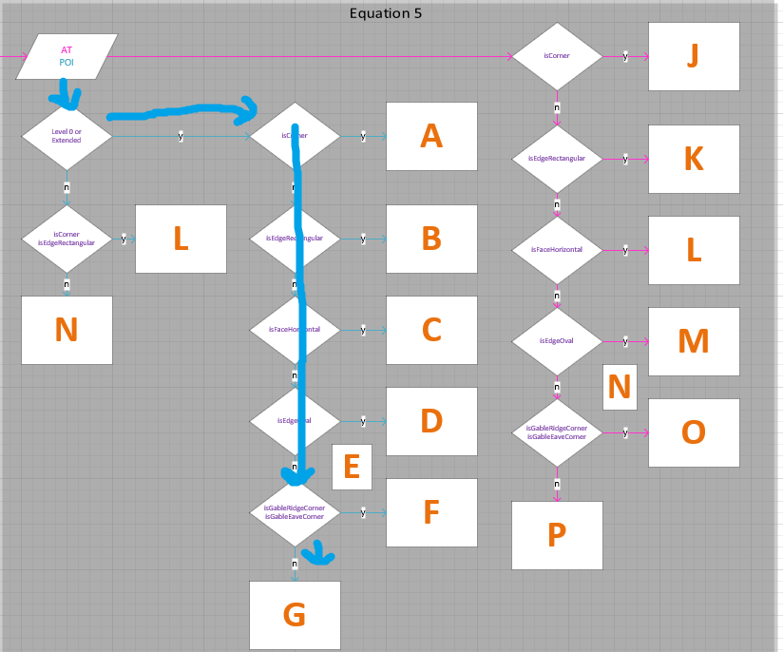

Ah-ha! The slope.

POI 11 & 12:

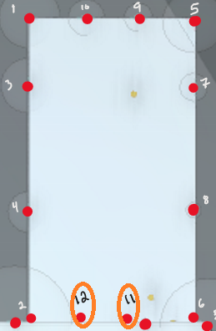

All Boolean values are correct, the calculation is off somehow.

H = H_Z – H_lvl0 = 9.55 – 5.7 = 3.85

$$Kimin=0.95{\left(\frac{3.845}{42.22}\right)}^{0.57}+1=1.2424$$

$$Kimax=0.46{\left(3.845+42.22\right)}^{0.568}*{42.22}^{-0.037}*{0.38}^{-0.508}+1=6.76605$$

$$Ki=\frac{6.76605-1.2424}{2}*0.515+1.2424=2.664$$

**The root cause of the problem here is pitch**. Pitch on spreadsheet is identified as 0.78

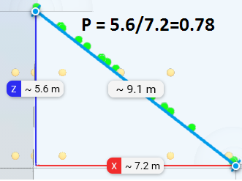

The pitch calculation for 1 is correct though…

POI 13:



Slope 0

POI 16 & 17:

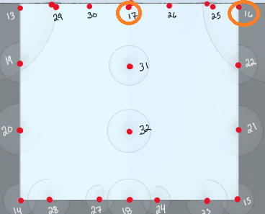

Slope 0 explains the values here.

POI 23-29:

POI 35-37:

POI 40-43:

POI 51:

POI 53-62: